Model Deployments
Model deployment means integrating the model and its resources into a production environment so that it can used to create predictions.
Deployment options:
- Self-hosted API
We deploy and host our ML models on our own infrastructures either on premises or in cloud using virtual machines or containers.
Here, we have to from setting up to manage necessary infrastructure such as web servers, load balancers, databases to serve the ml models as APIs.
- Managed API
These are the cloud-based services that provides a fully managed env for deploying and hosting our ML models as API.
In AWS, Sagemaker AI provides this facility to build, deploy and manage our ML models. This service abstracts the underlying infrastructure management so that we can focus on building and deploying ML models.

Fundamentals of MLOps
MLOps combines people, technology, and processes to deliver collaborative ML solutions.
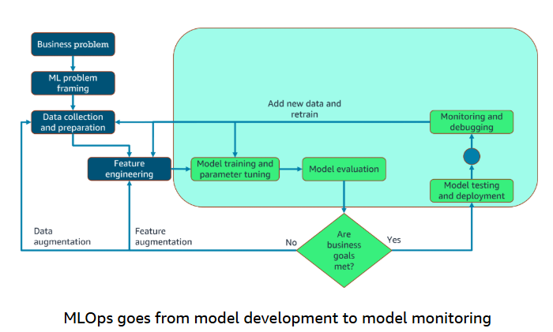
MLOps refers to the practice of operationalizing and streamlining the end-to-end machine learning lifecycle from model development and deployment to monitoring and maintenance. It helps ensure that models are not just developed but also deployed, monitored, and retrained systematically and repeatedly.
It is an extension of the DevOps principles and practices to the specific domain of machine learning systems.
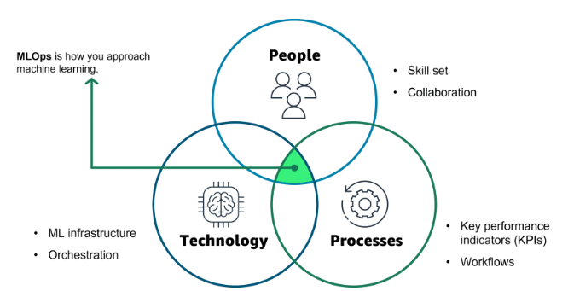
Like DevOps, MLOps relies on a collaborative and streamlined approach to the machine learning development lifecycle. It is the intersection of people, process, and technology that optimizes the end-to-end activities required to develop, build, and operate machine learning workloads.
Using MLOps
First: Why normal software practices are NOT enough for ML?
In a normal app:
- You write code → test it → deploy it
- If it works today, it will likely work the same tomorrow
But in ML apps:
- You train a model on data
- That data changes over time
👉 So even if your code doesn’t change, your model performance can degrade
This problem is called:
- Data drift (data distribution changes)
- Concept drift (relationship between input & output changes)

⚠️ Example (very important to understand)
Imagine you built a model to:
- Predict loan approval
Initially:
- Trained on past customer data → works great
After a few months:
- Economy changes
- User behavior changes
- New types of applicants appear
👉 Your model becomes less accurate, even though:
- Code = same
- Model = same

💡 So what’s the core problem?
ML systems are not just:
“code-based systems”
They are:
data + model + code systems
And data keeps changing

🚀 What is MLOps?
MLOps = Machine Learning + DevOps
It is a set of:
- practices
- tools
- processes
that help you build, deploy, and maintain ML systems reliably

🧠 Key Idea (Very Important)
MLOps treats ML systems like living systems, not static ones.
👉 Instead of:
"Build once, deploy forever"
We think:
"Continuously monitor, retrain, and improve"

🏗️ What makes ML apps different?
1. 📊 Data dependency
- Performance depends on data quality
- Bad data = bad model

2. 🔄 Model decay over time
- Models age
- Need retraining regularly

3. ⚙️ Complex pipelines
Not just one step:
- Data collection
- Data cleaning
- Feature engineering
- Training
- Evaluation
- Deployment

4. 📈 Evaluation is tricky
- Not just “does it run?”
- But:
  - Accuracy
  - Precision/Recall
  - Business impact

🔧 What MLOps actually does
Let’s map it to the paragraph you gave:

🔹 1. Project Management (ML-specific)
In normal projects:
- Tasks = coding features
In ML:
- Tasks =
  - collecting data
  - labeling data
  - experimenting with models
👉 MLOps helps manage:
- experiments (which model worked best?)
- versions (which dataset was used?)

🔹 2. CI/CD (Continuous Integration / Delivery)
In normal DevOps:
- CI/CD = test code → deploy code
In MLOps:
- You also need to:
  - retrain models automatically
  - test model performance
  - deploy new models safely
👉 Example pipeline:
- New data arrives →
- Model retrains →
- If performance improves →
- Deploy new model

🔹 3. Quality Assurance (QA)
Normal QA:
- Check bugs in code
ML QA:
- Check:
  - model accuracy
  - fairness (bias)
  - robustness
👉 Example:
- Does model perform worse for certain groups?
- Does it fail on edge cases?

🧩 Putting it all together
MLOps creates a system like this:
Data → Train Model → Evaluate → Deploy → Monitor → Retrain → Repeat
👉 It’s a continuous loop, not a one-time process

🎯 Benefits (from your paragraph)
✅ 1. Improve delivery time
- Faster model deployment
- Automated pipelines

✅ 2. Reduce defects
- Catch issues early:
  - bad data
  - poor model performance

✅ 3. Make data science more productive
- Less manual work
- More automation
- Better experiment tracking
Key principles of MLOps
Version control
For reproducibility, machine learning workflows must track changes to assets like data, code, and models. It can be rolled back to previous versions when needed.
Overall, version control and code review provide reproducible, trustworthy machine learning.
Automation
For repeatability, consistency, and scalability, you can automate the various stages in the machine learning pipeline. This includes the data ingestion, pre-processing, model training, and validation and deployment stages.

Automated testing helps you discover problems early for fast error fixes and learnings.
CI/CD
Through automation, you can continuously test and deploy assets in the following ways:
- Continuous integration extends the validation and testing of code to data and models in the pipeline.
- Continuous delivery automatically deploys the newly trained model or model prediction service.
- Continuous training automatically retrains ML models for redeployment.
- Continuous monitoring uses data monitoring and model monitoring of metrics related to business.
Model Governance
Good governance of machine learning systems requires close collaboration between data scientists, engineers, and business stakeholders. Clear documentation, effective communication channels, and feedback mechanisms help align everyone and improve models over time. It is also crucial to protect sensitive data, secure access, and meet compliance rules. A structured process for reviewing, validating, and approving models before deployment checks for fairness, bias, and ethics. Governance manages all aspects of systems for efficiency.
Implementing MLOps
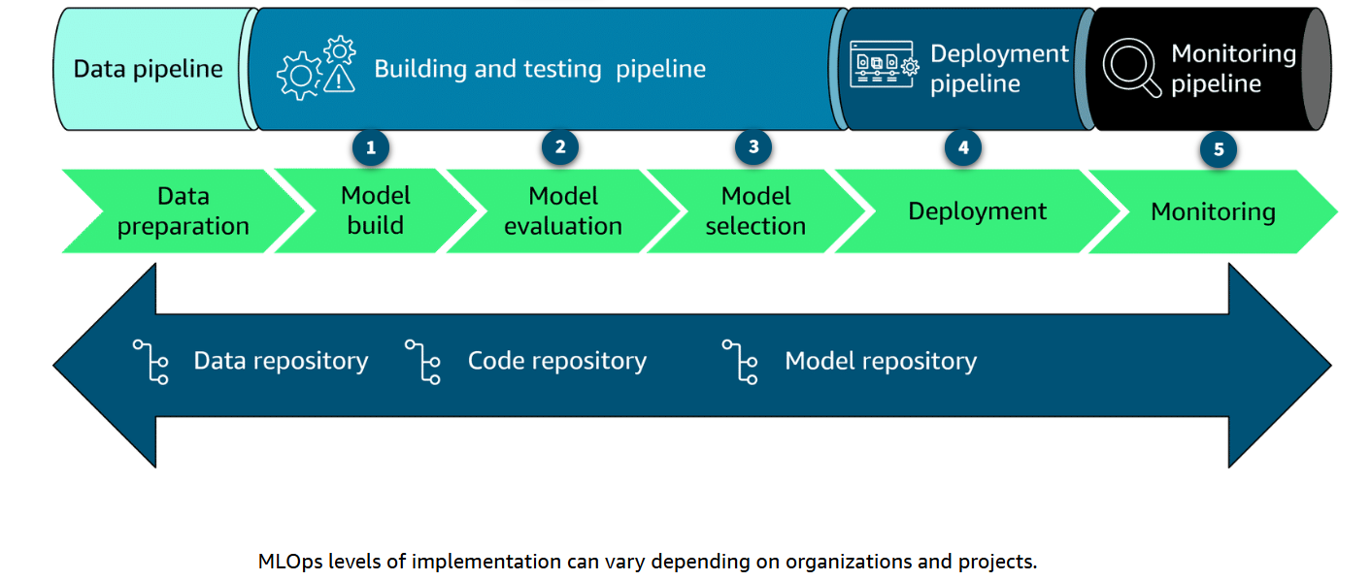

AWS services for MLOps
